

**ONLINE GROCERY STORE**

**PROJECT PART - III**



**JAYA PRAKASH REDDY MALKARAM**

**STUDENT ID: C0746329**

**WEB TECHNOLOGIES – II**

**INTERACTIVE MEDIA MANAGEMENT – 2019W**

**PART-3: (12th & 13th week’s)**:

In part 3, I would like to implement adding products to the website and categorize them into their types and adding add to cart.

I have added all the products in every page in this part.

**HOME:**

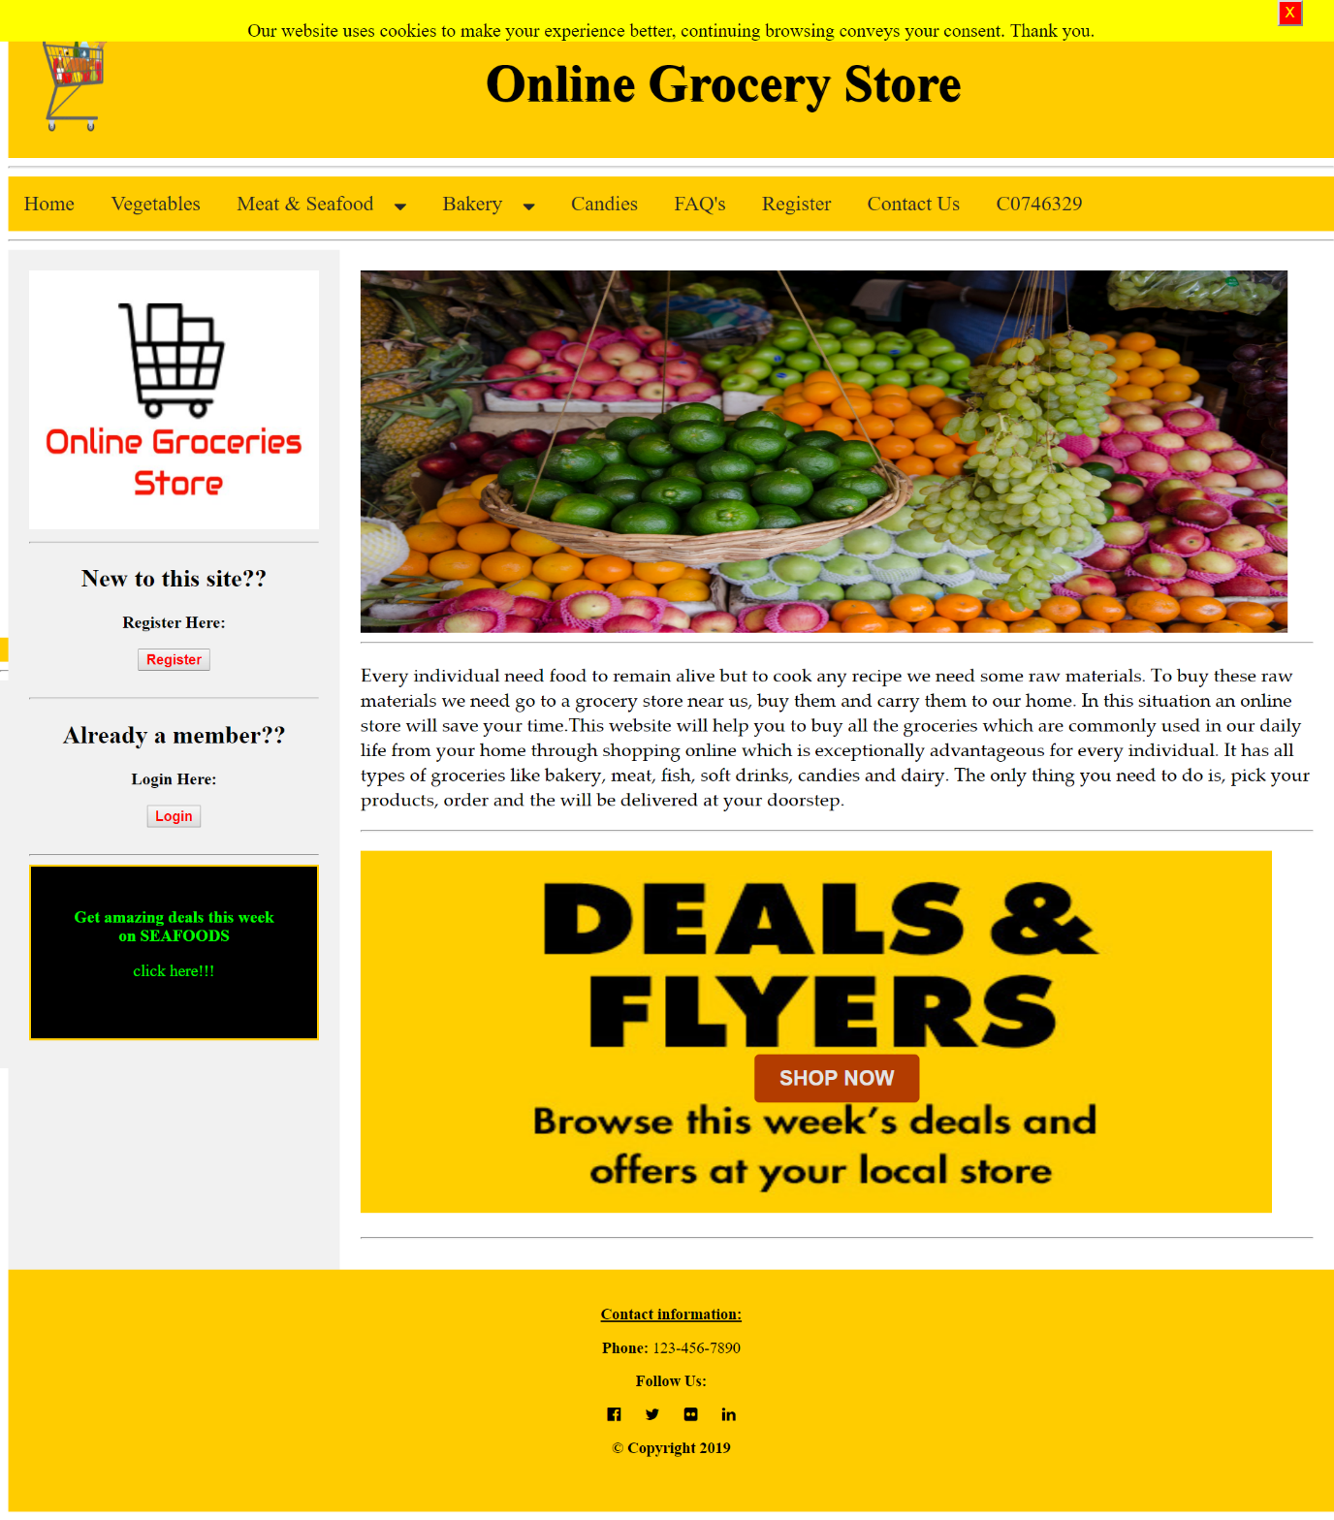

**VEGETABLES:**

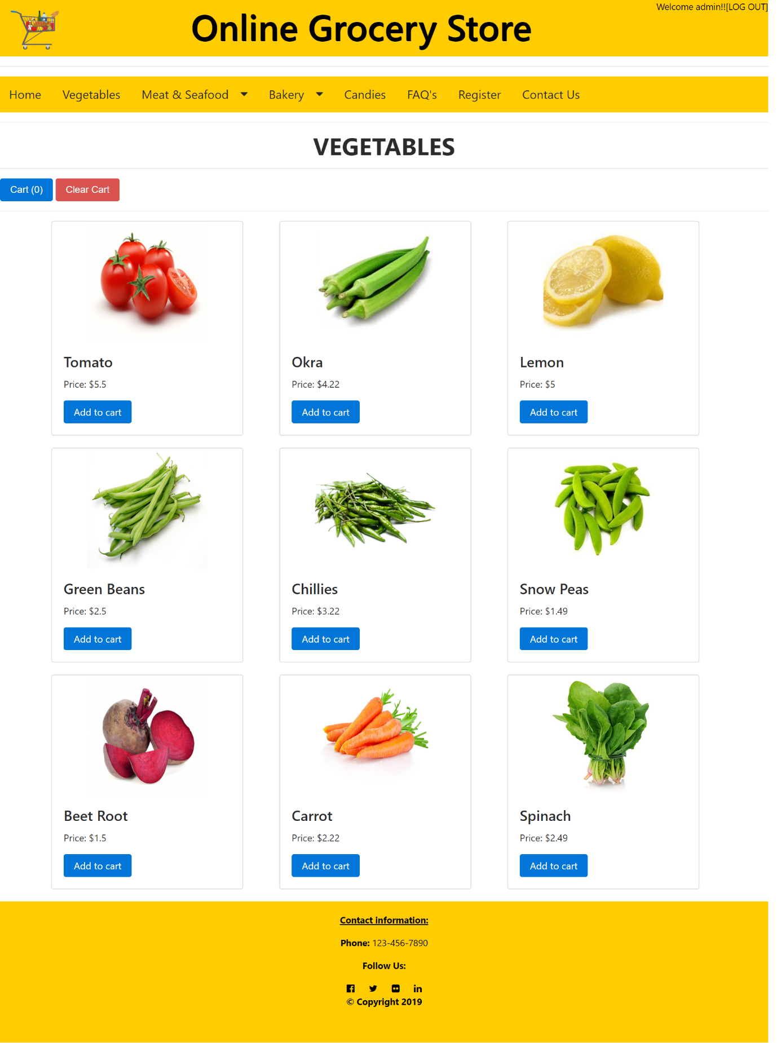

**MEAT:**

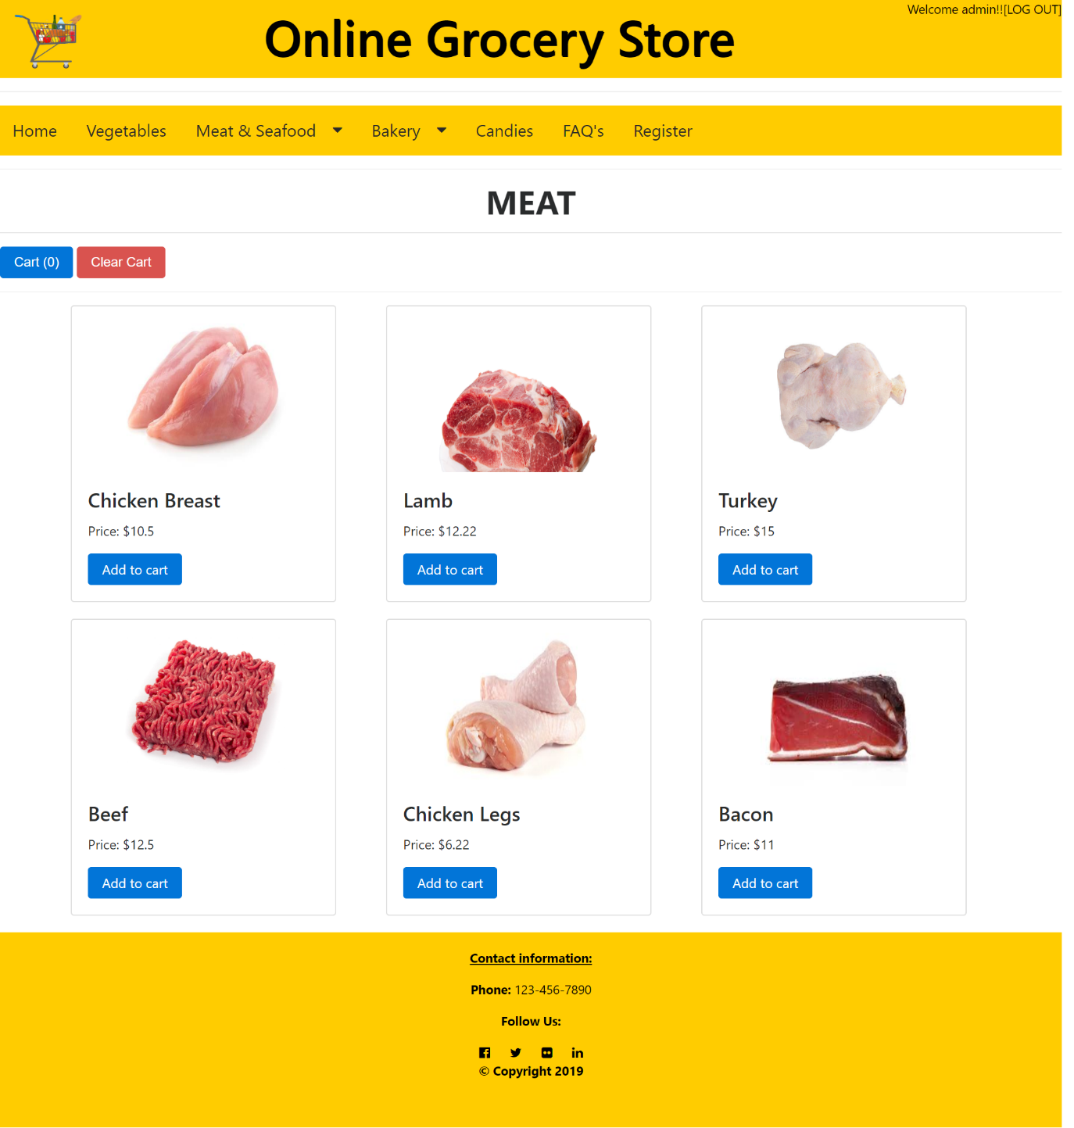

**SEA FOOD:**

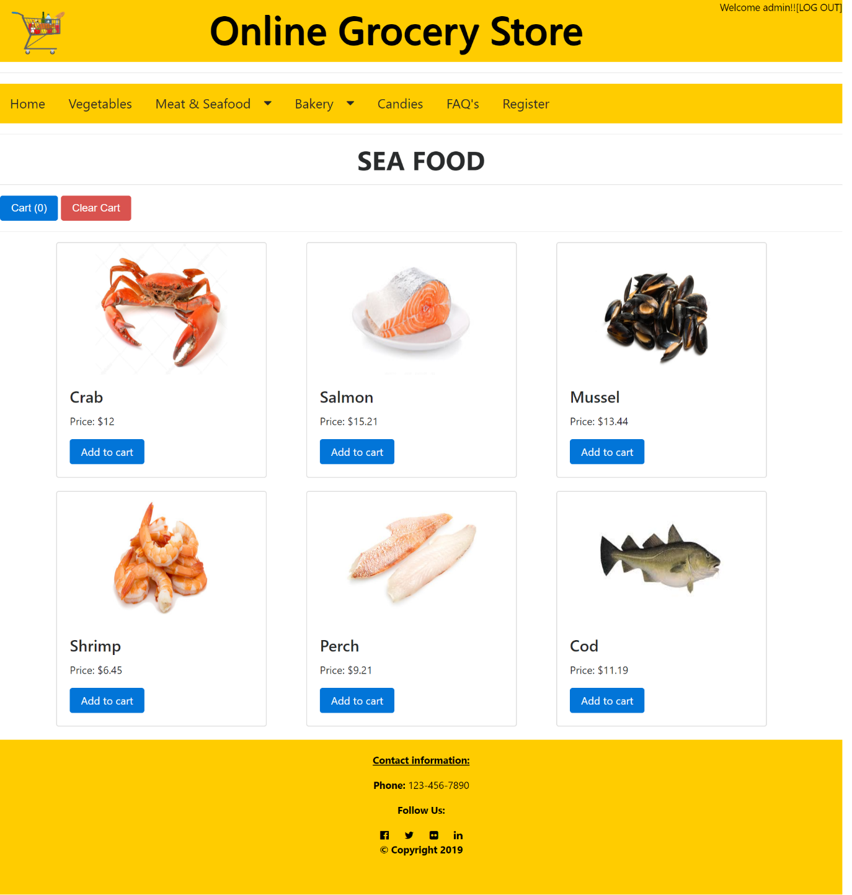

**SOFT DRINKS:**

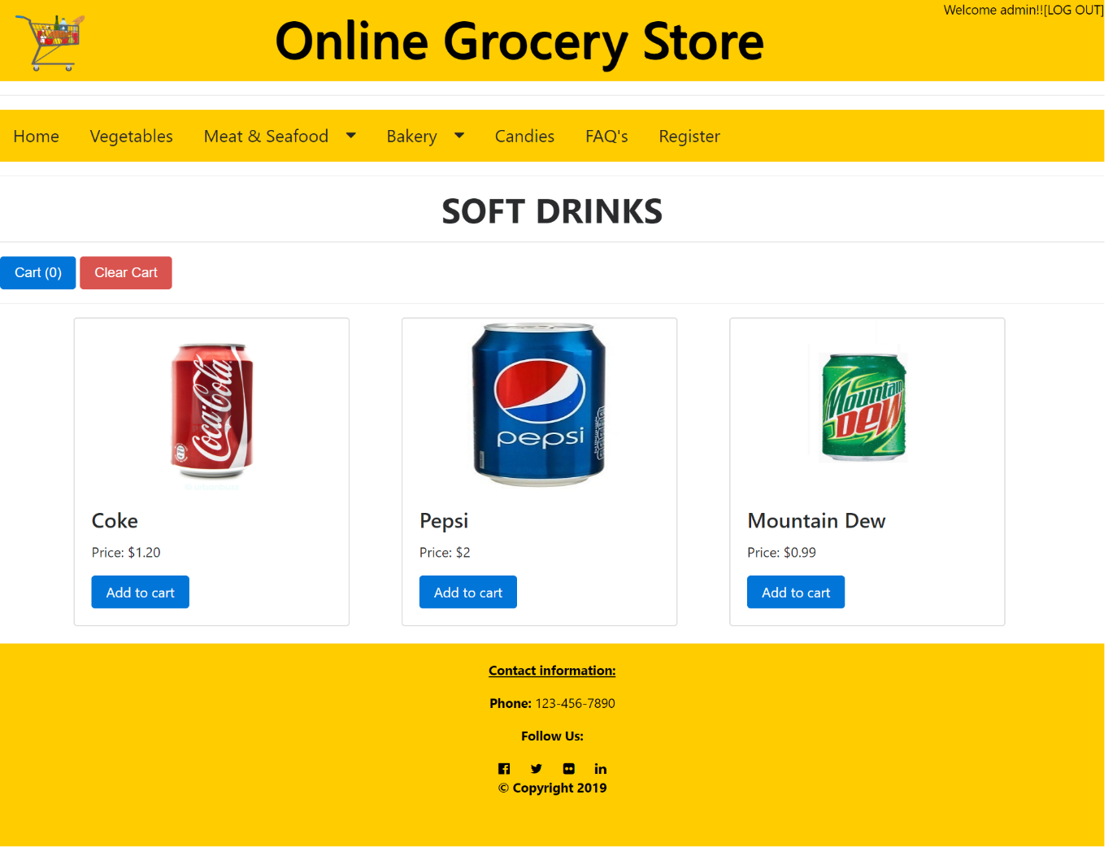

**CAKES:**

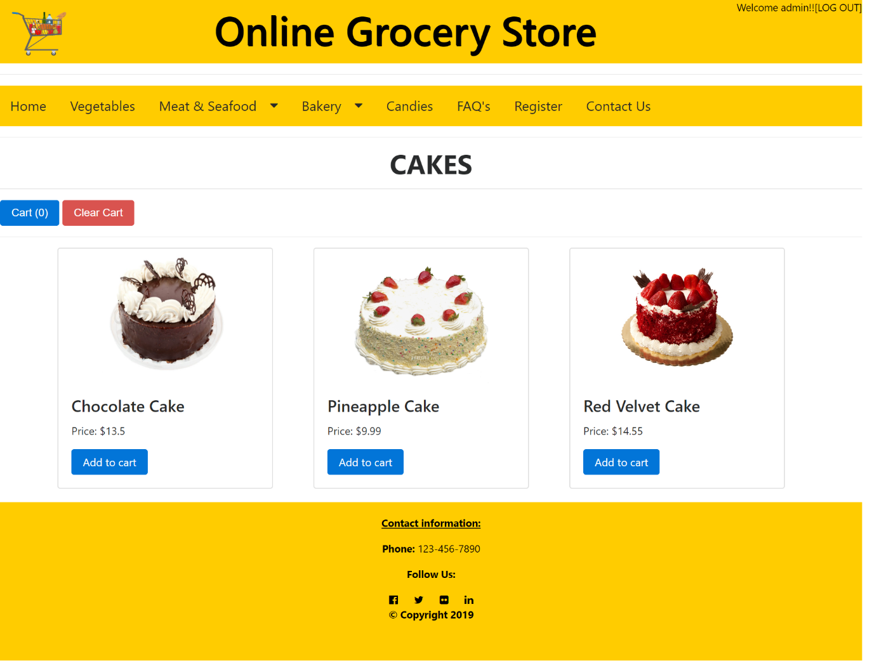

**CANDIES:**

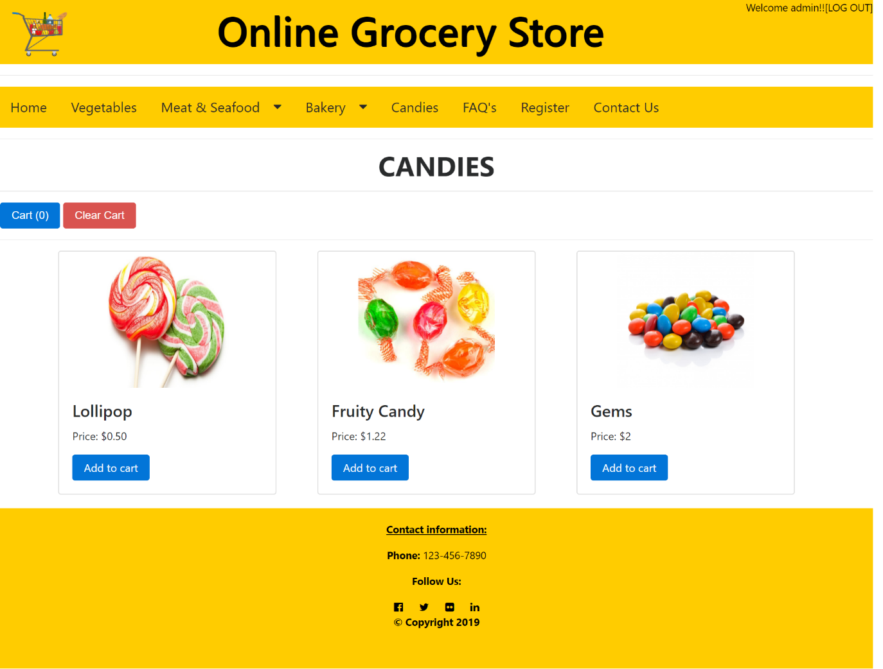

**FAQ’S:**

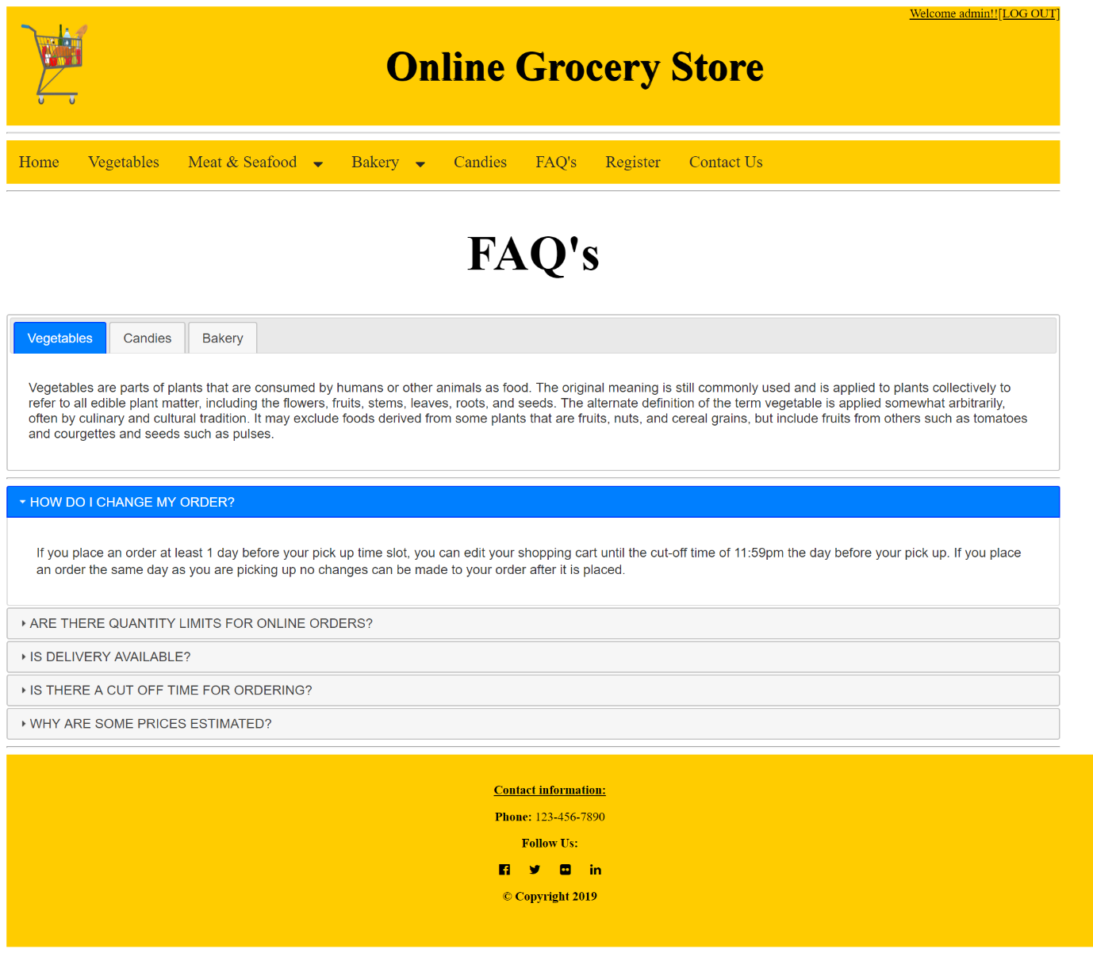

**REGISTER:**

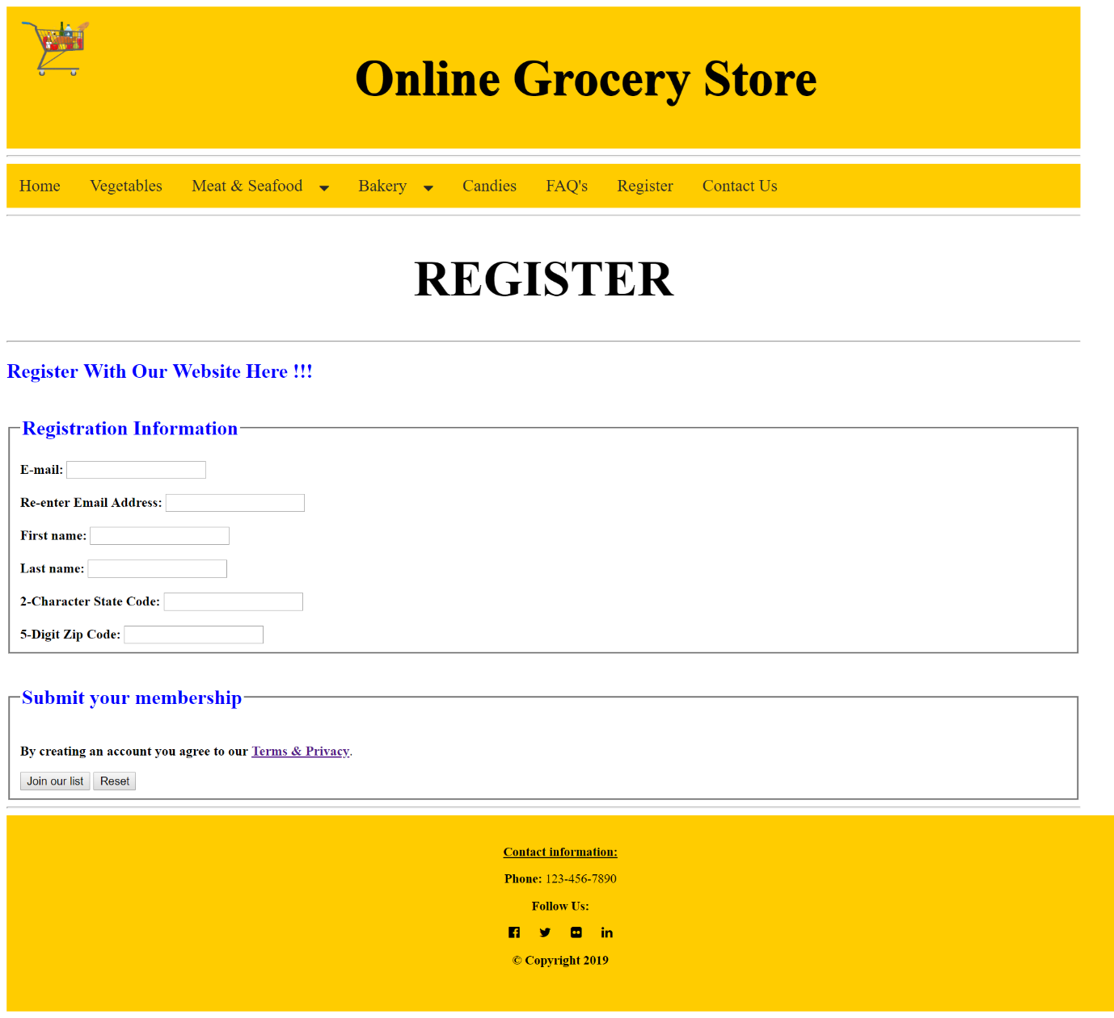

**CONTACTS US:**

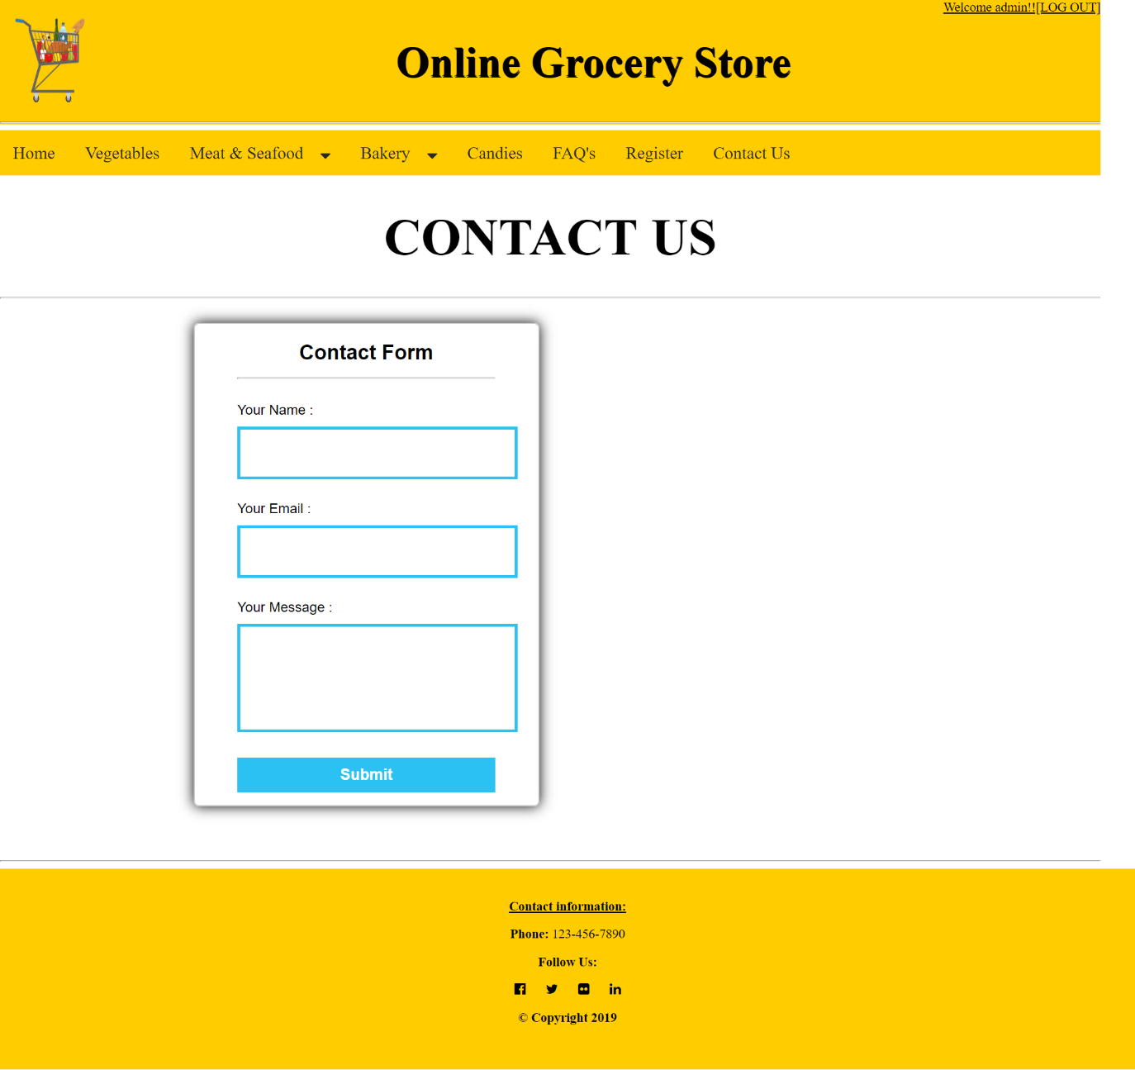

**LOG IN:**

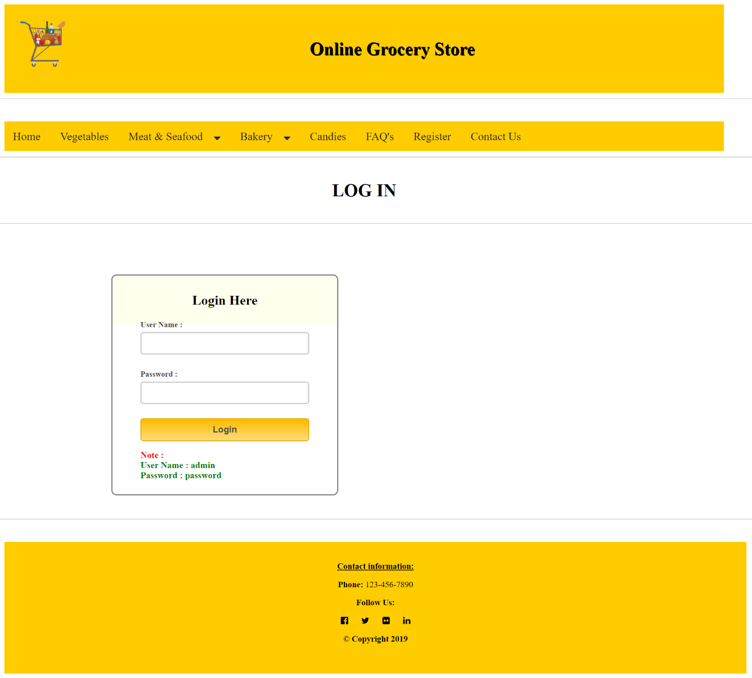

**NAME:**

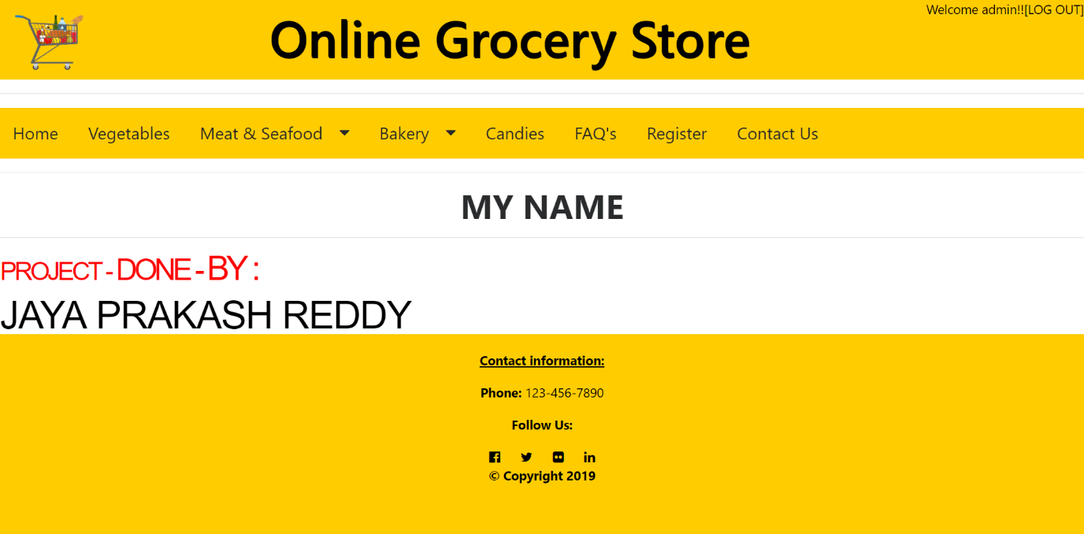

**CART:**

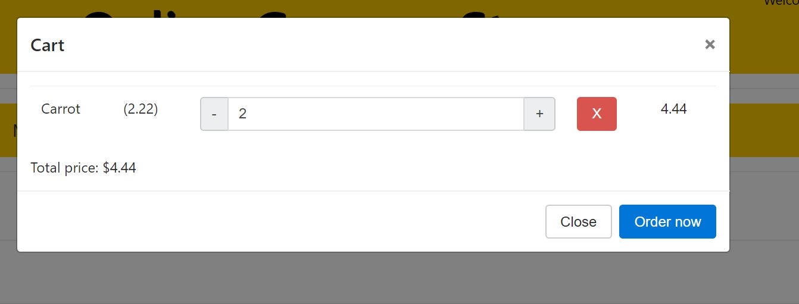

**CHECKOUT:**

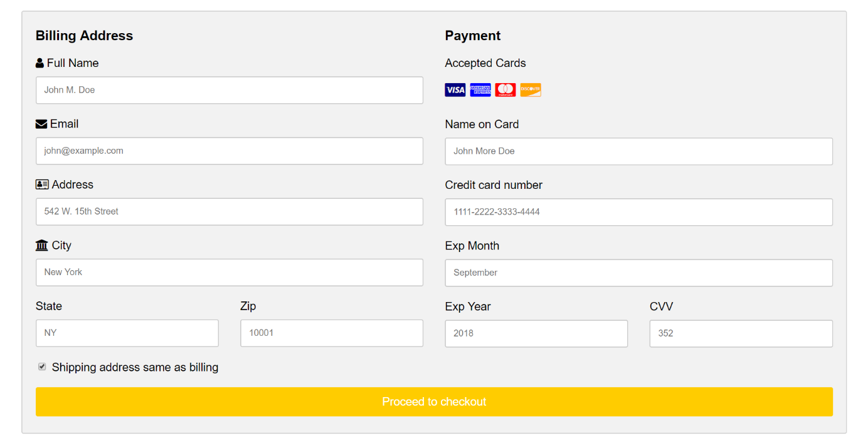

**THANK YOU NOTE:**

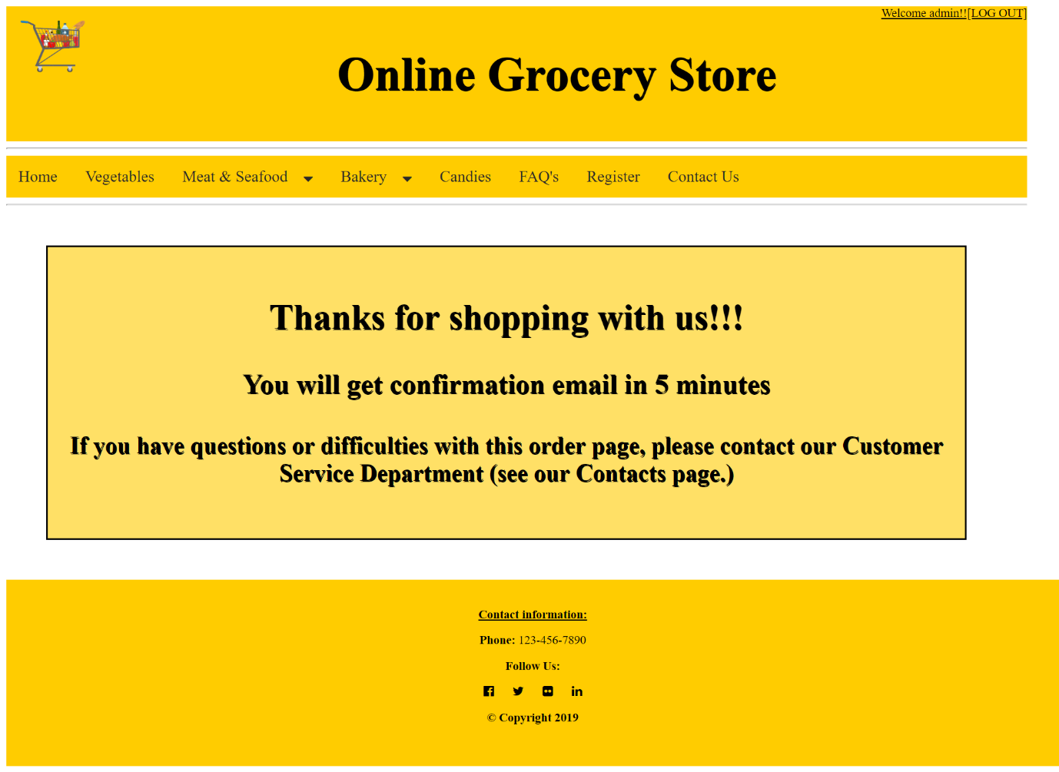

THANK YOU